**Engineering Exploration**

(ASE-3101)



PROJECT REPORT

BATCH-2017

|  |
| --- |
| **Muskaan Sharma-1711981172**  **Rashmi Verma-1711981233**  **Shivesh Sharma-1711981286**  **Shreya Sardana-1711981289** |

**Mr.Gurmohan Singh:**

**Ms. Monica parmar:**

**Ms. Latika:**

**Mr. Pankaj Dhiman:**

**NEED STATEMENT**

To be dressed in a proper manner is professional requirement of a well-groomed student. Shoes happen to be an important component of the whole attire. Design a lost cost show shining machine which can be installed at various places in the campus and can be used by students at will.

**GANTT CHART: PROJECT TIMELINE**

|  |  |  |  |  |  |  |  |  |  |  |  |  |  |
| --- | --- | --- | --- | --- | --- | --- | --- | --- | --- | --- | --- | --- | --- |
|  | **Weeks** | **1** | **2** | **3** | **4** | **5** | **6** | **7** | **8** | **9** | **10** | **11** | **12** |
| **Stage 1** | **Need statement** | **\*\*** |  |  |  |  |  |  |  |  |  |  |  |
| **Stage 2** | **OFC** |  | **\*\*** |  |  |  |  |  |  |  |  |  |  |
| **Stage 3** | **Problem statement** | **\*\*** |  |  |  |  |  |  |  |  |  |  |  |
| **Stage 4** | **OFC Analysis** |  |  | **\*\*** |  |  |  |  |  |  |  |  |  |
| **Stage 5** | **Identifying multiple solution** |  |  |  | **\*\*** | **\*\*** |  |  |  |  |  |  |  |
| **Stage 6** | **Choosing the best solution** |  |  |  |  |  | **\*\*** |  |  |  |  |  |  |
| **Stage 7** | **Conceptual Design and optimization** |  |  |  |  |  |  | **\*\*** |  |  |  |  |  |
| **Stage 8** | **Prototyping** |  |  |  |  |  |  |  | **\*\*** | **\*\*** | **\*\*** | **\*\*** |  |
| **Stage 9** | **Testing** |  |  |  |  |  |  |  |  |  |  |  | **\*\*** |
| **Stage 10** | **Documentation** |  |  | **\*\*** | **\*\*** | **\*\*** | **\*\*** | **\*\*** | **\*\*** | **\*\*** | **\*\*** | **\*\*** | **\*\*** |

**Objective-Function-Constraint Identification (Tick)**

|  |  |  |  |
| --- | --- | --- | --- |
| **Characteristics** | **Objective** | **Constrains** | **Functions** |
| Attractive |  |  |  |
| Small Size |  |  |  |
| Low Weight |  |  |  |
| Portable |  |  |  |
| Durable |  |  |  |
| Low Cost |  |  |  |
| Safe |  |  |  |
| Soft Brush Material |  |  |  |
| Easy to Use |  |  |  |
| Polishing Quality/Shining Quality |  |  |  |
| Automatic Working |  |  |  |
| Low power consumption |  |  |  |

**PROBLEM STATEMENT**

To design an attractive, small, portable and efficient shoe shiner which is durable, easy to use for all age groups and has a cost of approx. Rs3,000/-

**Pair-Wise Comparison Charts**

**PCC Chart-Muskaan Sharma**

|  |  |  |  |  |  |  |  |
| --- | --- | --- | --- | --- | --- | --- | --- |
|  | Attractive | Portable | Durable | Easy to use | Polishing quality | score | rank |
| Attractive | --- | 0 | 0 | 1 | 0 | 1 | 5 |
| Portable | 0 | --- | 1 | 1 | 1 | 3 | 2 |
| Durable | 0 | 0 | --- | 1 | 0 | 1 | 4 |
| Easy to use | 0 | 1 | 1 | --- | 1 | 3 | 1 |
| Polishing quality | 0 | 0 | 1 | 0 | --- | 1 | 3 |

**PCC Chart- Rashmi Verma**

|  |  |  |  |  |  |  |  |
| --- | --- | --- | --- | --- | --- | --- | --- |
|  | Attractive | Portable | Durable | Easy to use | Polishing quality | score | rank |
| Attractive | --- | 0 | 0 | 1 | 0 | 1 | 5 |
| Portable | 0 | --- | 1 | 0 | 0 | 1 | 2 |
| Durable | 1 | 1 | --- | 1 | 1 | 4 | 1 |
| Easy to use | 0 | 0 | 1 | --- | 0 | 1 | 3 |
| Polishing quality | 0 | 1 | 0 | 0 | --- | 1 | 4 |

**PCC Chart- Shivesh Sharma**

|  |  |  |  |  |  |  |  |
| --- | --- | --- | --- | --- | --- | --- | --- |
|  | Attractive | Portable | Durable | Easy to use | Polishing quality | score | rank |
| Attractive | --- | 0 | 1 | 0 | 0 | 1 | 4 |
| Portable | 0 | --- | 0 | 0 | 0 | 0 | 5 |
| Durable | 0 | 0 | --- | 1 | 1 | 2 | 2 |
| Easy to use | 1 | 0 | 0 | --- | 1 | 2 | 3 |
| Polishing quality | 1 | 0 | 1 | 1 | --- | 3 | 1 |

**PCC Chart- Shreya Sardana**

|  |  |  |  |  |  |  |  |
| --- | --- | --- | --- | --- | --- | --- | --- |
|  | Attractive | Portable | Durable | Easy to use | Polishing quality | score | rank |
| Attractive | --- | 1 | 0 | 0 | 1 | 2 | 4 |
| Portable | 1 | --- | 0 | 0 | 0 | 1 | 5 |
| Durable | 0 | 1 | --- | 1 | 0 | 2 | 3 |
| Easy to use | 0 | 0 | 1 | --- | 1 | 2 | 1 |
| Polishing quality | 1 | 0 | 1 | 0 | --- | 2 | 2 |

**Final PCC Evaluation**

|  |  |  |  |  |  |  |
| --- | --- | --- | --- | --- | --- | --- |
| **Objectives** | Attractive | Portable | Durable | Easy to use | Polishing quality | Score |
| Attractive | --- | 0+0+0+1 | 0+1+1+0 | 1+1+0+0 | 0+0+0+1 | 7 |
| Portable | 0+0+0+1 | --- | 1+1+0+0 | 1+0+0+0 | 1+0+0+0 | 6 |
| Durable | 0+1+0+0 | 0+1+0+1 | --- | 1+1+1+1 | 0+1+1+0 | 10 |
| Easy to use | 0+0+1+0 | 1+0+0+0 | 1+1+0+1 | --- | 1+0+1+1 | 9 |
| Polishing quality | 0+0+1+1 | 0+1+0+0 | 1+0+1+1 | 0+0+1+0 | --- | 8 |

**Ranking of Objectives**

|  |  |  |
| --- | --- | --- |
| **Objectives** | **Score** | **Rank** |
| Attractive | 7 | 4 |
| Portable | 6 | 5 |
| Durable | 10 | 1 |
| Easy to use | 9 | 2 |
| Polishing quality | 8 | 3 |

**Constraint Analysis Chart**

|  |  |
| --- | --- |
| **Constraint** | **Limit** |
| Small size | It should be small in size so that it can be placed anywhere and can be accessed easily not more than 1ft*1ft*1ft. |
| Low weight | It should be less in weight so that it can be shifted from one place to another easily ,weight not exceeding 8 kg. |
| Low cost | Maximum cost of manufacturing not exceeding 3000 Rs. |
| Safe | It should not contain any unsafe elements which are hazards to human health. |
| Soft Brush Material | Brushes should be soft (sponge) for good smooth working . |

**Morphological Chart**

|  |  |  |  |  |  |
| --- | --- | --- | --- | --- | --- |
| **Functions** | **Sub-functions** | **Means** | | | |
| **Option-1** | **Option-2** | **Option-3** | **Option-4** |
| **Automated cleaning and shining** | Sensors | IR Sensor | PIR | LDR | Ultrasonic sensor |
| **Less Power consumption** | Electronic components | Controller | converter | Diodes & capacitors | Resistances |
|  | Material used | Plastic | Wood | Fibre | Cardboard |
| **Interactive** | Audio/Video input | Arduino uno | buzzer | Sensors | Switches |

**Generating Multiple Concepts**

|  |  |
| --- | --- |
| **Multiple Concepts** | **Concept Color** |
| **Concept-1** |  |
| **Concept-2** |  |
| **Concept-3** |  |
| **Concept-4** |  |

**Analysis of Multiple Concepts Generated**

|  |  |  |  |  |  |
| --- | --- | --- | --- | --- | --- |
| **Criteria** | | **Concept-1** | **Concept-2** | **Concept-3** | **Concept-4** |
| **Objectives** | Attractive | -- |  | -- |  |
| Portable |  |  | -- |  |
| Polishing quality |  | -- |  |  |
| Durable | -- |  |  |  |
| Easy to use |  | -- |  |  |
| **Constraints** | Softbrush material |  | -- |  |  |
| Safe |  |  |  |  |
| Low weight | -- |  | -- |  |
| Small size |  | -- |  |  |
| Low Cost |  |  |  |  |

**Final Design Decision: Pugh Chart**

|  |  |  |  |  |  |
| --- | --- | --- | --- | --- | --- |
| **Objectives** | **Weightage**  **(1-10)** | **Concept-1** | **Concept-2** | **Concept-3** | **Concept-4** |
| Durable | 9 | 0 | 9 | 9 | 9 |
| Easy to use | 8 | 8 | 0 | 8 | 8 |
| Polishing quality | 7 | 0 | 0 | 7 | 7 |
| Portable | 6 | 6 | 6 | 0 | 6 |
| Attractive | 4 | 0 | 4 | 0 | 4 |
| **Final Score 34** | | 14 | 19 | 24 | 34 |

**BLACK BOX DIAGRAM**

MATERIAL(SHOES)

SHOE SHINES (BRUSHES ROTATORY ACTION)

ENERGY(AC OPERATING)

**Transparent box diagram**

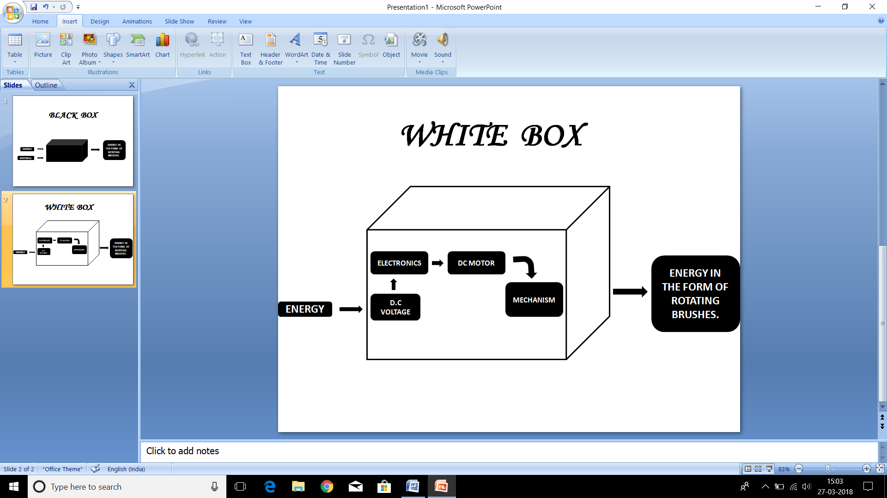

**Conceptual Design**

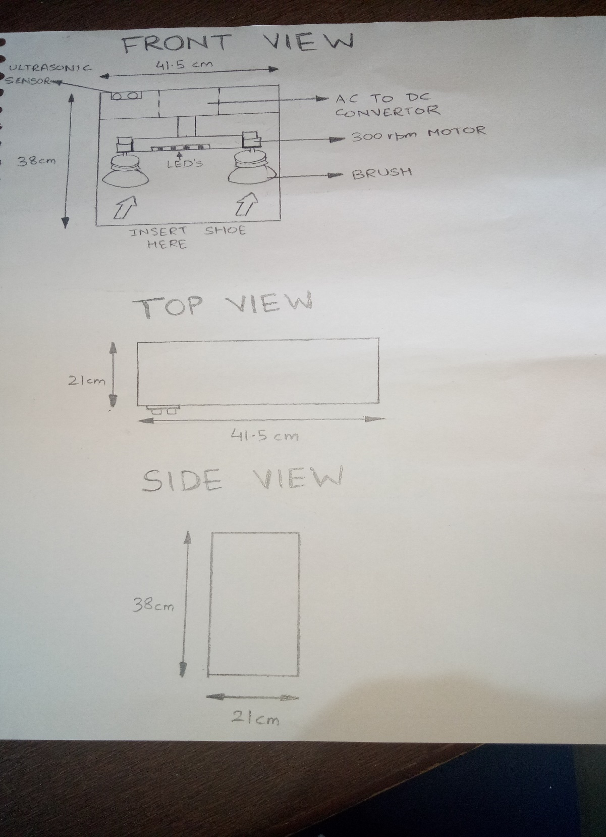

**Advanced Conceptual Design**

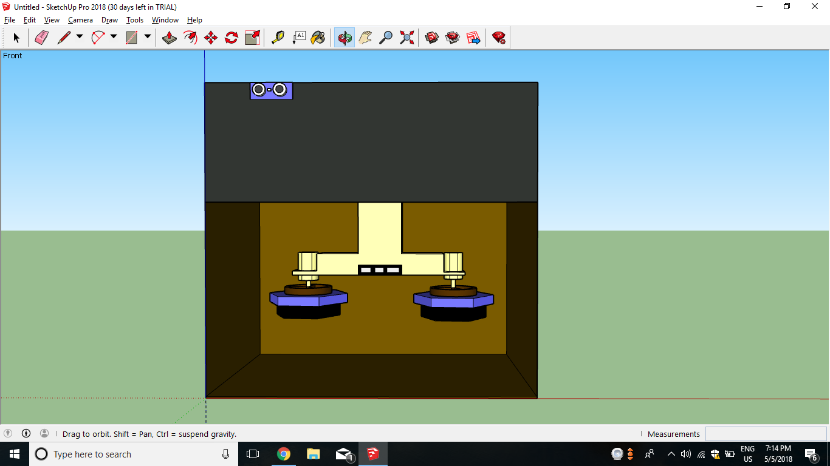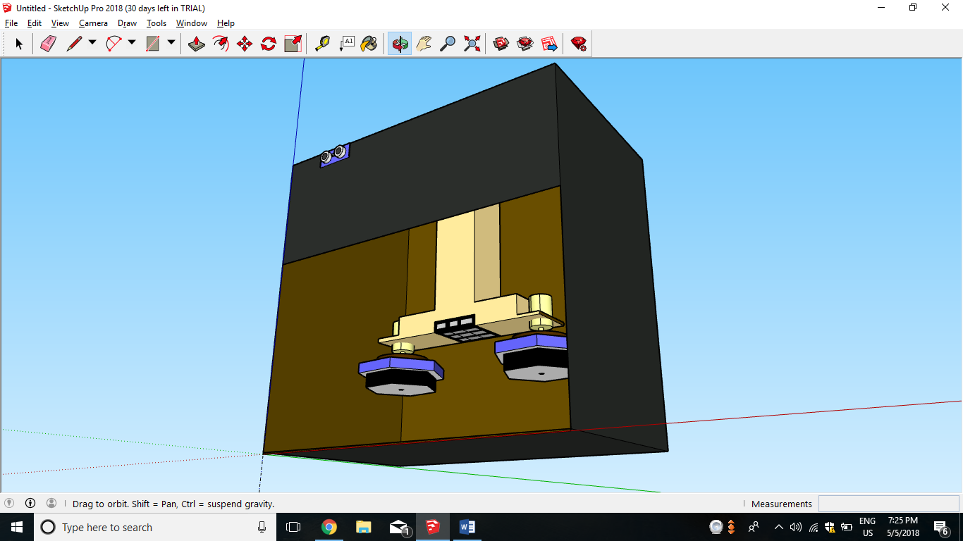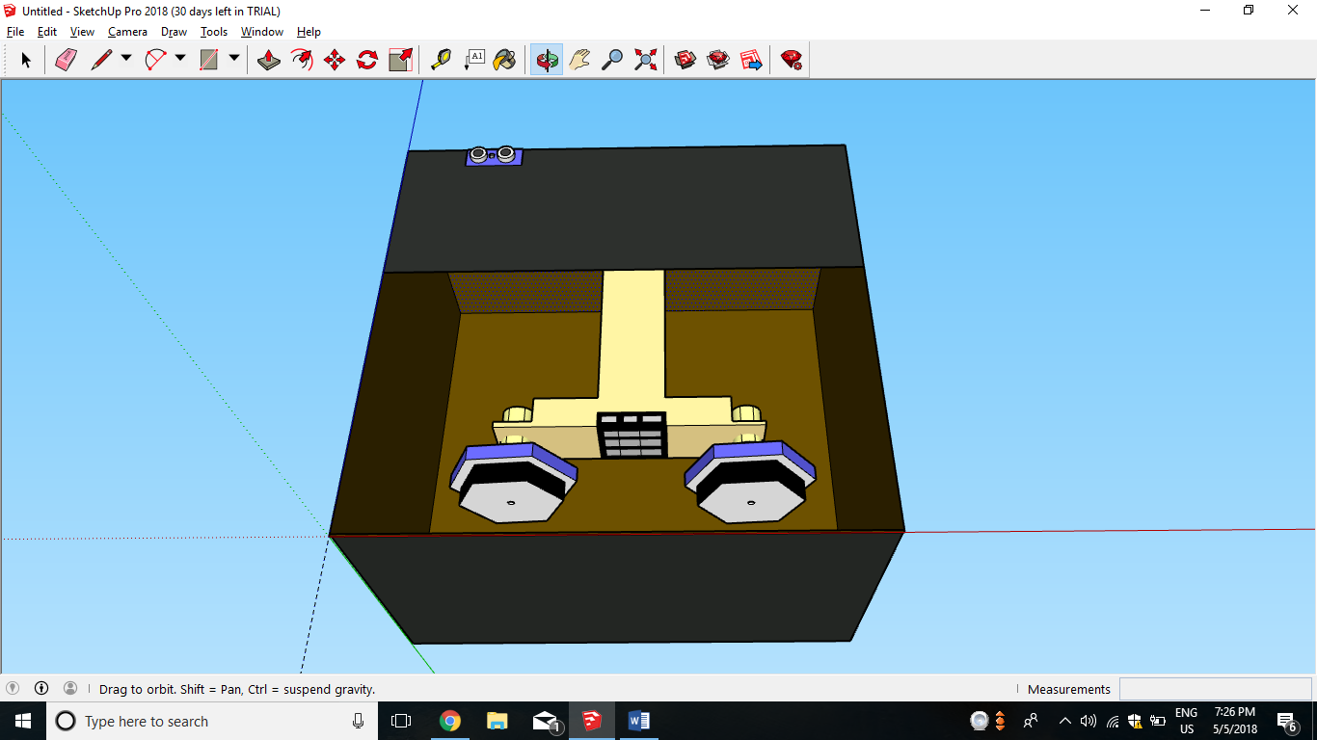

**PROTOTYPE PHOTOGRAPHS**

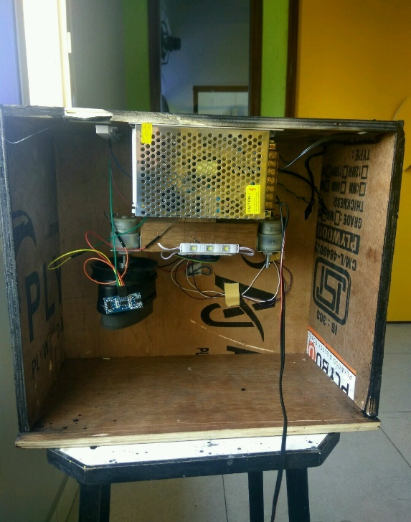 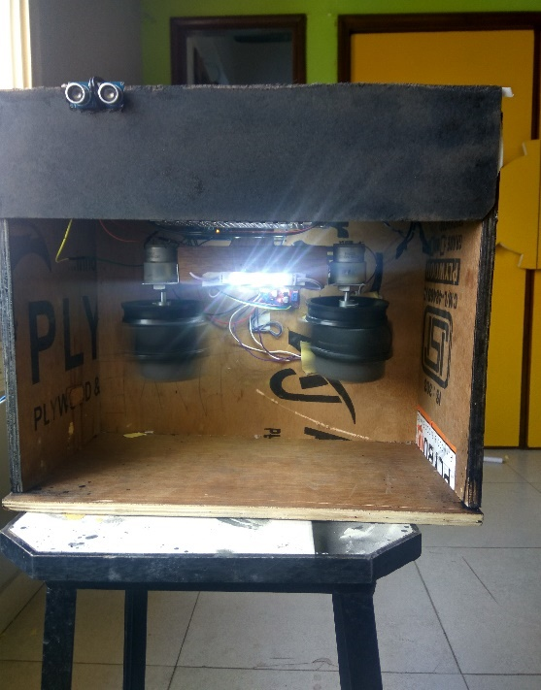

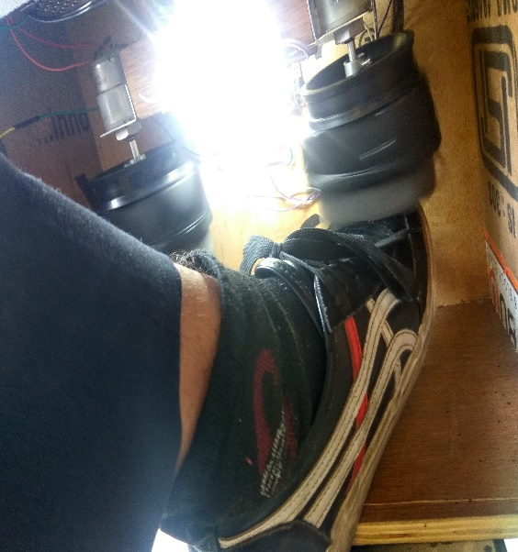

**TEAM FORMING CHART**

|  |  |  |  |  |
| --- | --- | --- | --- | --- |
| **S. No.** | **Name of the students** | **ID** | **Role** | **Responsibility** |
| **1** | Muskaan Sharma | 1711981172 | Project Manager | Managing Project Details,Report |
| **2** | Rashmi Verma | 1711981233 | Co-leader | Helping in combining and collecting materials |
| **3** | Shivesh Sharma | 1711981286 | Leader | Helped in wiring and Assembling the project |
| **4** | Shreya Sardana | 1711981289 | Project Manager | Helped in coding arduindo |

**TEAM STORMING Chart**

|  |  |  |  |  |
| --- | --- | --- | --- | --- |
| **Meeting no.** | **Date** | **Attendance** | **Topic discussed/Problem** | **Follow-up** |
| 1 | 21/01/2018 | All present | Rough model discussion | Electronic components to be used |
| 2 | 11/02/2018 | All present | OFC and PCC analysis | Ranking |
| 3 | 17/03/2018 | All present | Morphological chart and pugh chart | Final Concept concluded |
| 4 | 24/03/2018 | All present | Making of model | Final documentation |
| 5 | 1/03/2018 | All present | Protyping discussion |  |

**BILL OF MATERIALS**

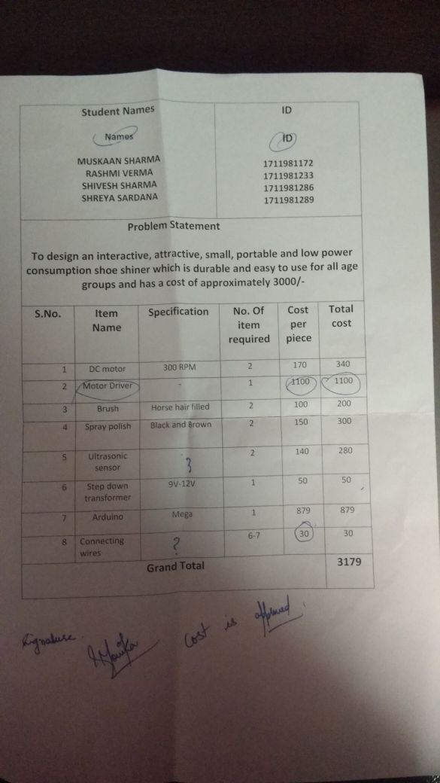

**FAILURE ANALYSIS**